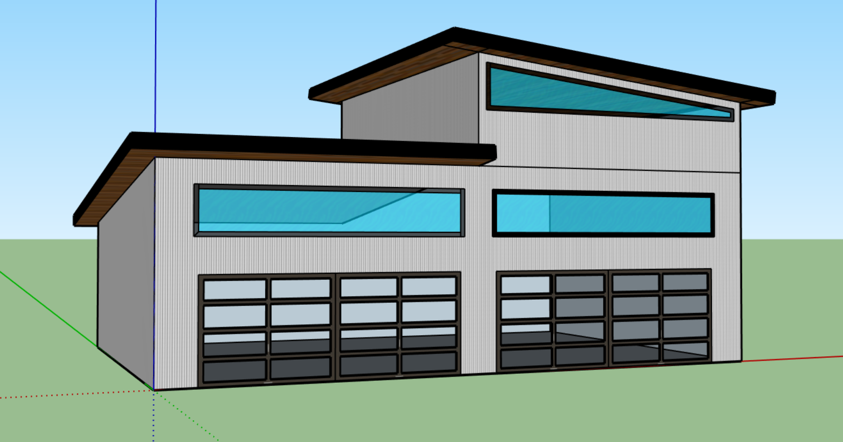
St. Paul’s Community Workshop – sketch up
Some ideas and hopes:
- Multipurpose: wood working, auto mechanics, wielding, gardening
- Air filtration
- Excellent lighting
- Easy access from parking lot
- Wide gentle sloping ramp to lower level at back
- Kitchenette
- Accessible washroom
- Meeting room
- Gardening storage on lower level back side
- Concrete pad on lower level back side

Will be built and furnished in stages using a possible land sale, grant money and donations.
Long-term goal is to hire a Community Workshop Outreach Director to oversee the program and ministry.
Safety certification program will be taught and administered so that small groups may eventually use the space without direct supervision of the CWO director. Similar idea to Food Safe certification model.
First stage of focus will be training and equipping for the CWO Ministry, other community groups will then be invited to use the space. This will include drop-in times that are open to the local community.
Community events will be hosted here: Show & Shine, Gardening Club Days, Women’s Car Maintenance Class, Basic Wood Working Class, Community BBQ, etc.
Community teachers and leaders will be invited to teach and guide a variety of user groups.

